 SEND Policy

Headteachers: | N.Hall and H.McConnell | Date: September 2026
Chair of governors: | D. Hall Date: September 2026
Next review: | September 2027

Introduction
At Mulbarton Primary we are a learning community aiming to provide an outstanding, broad curriculum in a stimulating and safe environment. We want everyone in our School to be happy, resilient and loved, showing respect for each other and the world we live in. We value diversity and individuality and strive to ensure everyone achieves their full potential in a nurturing atmosphere of support and encouragement.

We are committed to providing a full and effective education, embracing equal opportunities for all.

This policy aims to:
- Set out how our school will support and make provision for pupils with special educational needs (SEND)
- Explain the roles and responsibilities of everyone involved in providing for pupils with SEND.

We value communication with parents and carers and aim to work in partnership to ensure children with SEND achieve their full potential.

Legislation
This policy has due regard to all relevant legislation including, but not limited to, the following:
- Local Government Act 1974
- Disabled Persons (Services, Consultation and Representation) Act 1986
- Children Act 1989
- Education Act 1996
- Education Act 2002
- Mental Capacity Act 2005
- Equality Act 2010
- The Equality Act 2010 (Disability) Regulations 2010
- Children and Families Act 2014
- The Special Educational Needs (Personal Budgets) Regulations 2014
- The Special Educational Needs and Disability (Amendment) Regulations 2015
- The Special Educational Needs and Disability (Detained Persons) Regulations 2015
- The UK General Data Protection Regulation (GDPR)
- Data Protection Act 2018
- Health and Care Act 2022
This policy has due regard to statutory and non-statutory guidance, including, but not limited to, the following:
- DfE (2015) ‘Special educational needs and disability code of practice: 0 to 25 years’
- DfE (2015) ‘Supporting pupils at school with medical conditions’
- DfE (2018) ‘Working Together to Safeguard Children 2018’
- DfE (2018) ‘Mental health and wellbeing provision in schools’
- DfE (2021) ‘School Admissions Code’
- DfE (2026) ‘Keeping children safe in education 2026’
- Equality and Human Rights Commission (EHRC) (2015) ‘Reasonable adjustments for disabled pupils’

Learners with SEND or disability
Under the Equality Act 2010, a disability is a physical or mental impairment which has a long-term and substantial adverse effect on a person’s ability to carry out normal day-to-day activities. For the purposes of this policy, a pupil is defined as having SEND if they have:
- A significantly greater difficulty in learning than most others of the same age.
- A disability or health condition that prevents or hinders them from making use of educational facilities used by peers of the same age in mainstream settings.
- Special educational provision that is additional to or different from that made generally for other children or young people of the same age by mainstream settings.

Areas of Special Educational Need
Children identified as having a special educational need (SEND) will be considered within one or more of the following categories of need:

- Communication and interaction
Children with speech, language and communication need (SLCN) may have difficulty in making themselves understood or in understanding the meaning of some or much of what they hear or read. This may result in problems taking part in conversations. Some children may have an Autism Spectrum Disorder (ASD) which could result in difficulties related to making sense of the world, imagination, distraction or distress from certain events such as change in routines.
- Cognition and learning
Children with learning needs may learn at a slower pace than other children and may have difficulty developing Literacy or Numeracy skills or understanding new concepts. Learning needs may be in addition to or as a result of other special educational needs. Children with a specific learning difficulty (SpLD) will have difficulties related to one or more of Dyslexia (reading and spelling), Dyscalculia (maths), DCD (co-ordination) and Dysgraphia (writing).
- Social, emotional and mental health difficulties
Difficulties with emotional and social development may result in delayed social skills and the inability to make or sustain relationships. Certain accompanying behaviours can also be observed such as becoming withdrawn or isolated or challenging, disruptive or disturbing behaviour. Unusual mood, behaviour and medically unexplained physical symptoms can be indicators of a mental health need.
- Sensory and/or physical needs
Many children can have their sensory and/or physical needs met through adaptations to the curriculum, teaching activities or physical environment under the guidance of the Equality Act 2010.
Further information about the four areas of SEND can be found in the SEND Code of Practice (2015).

Identifying a child with SEND
The school recognises that early identification and effective provision improves long term outcomes for pupils. Class teachers will make regular assessments of progress for all pupils and identify those whose progress:
- Is significantly slower than that of their peers starting from the same baseline
- Fails to match or better the child’s previous rate of progress
- Fails to close the attainment gap between the child and their peers
- Widens the attainment gap
This may include progress in areas other than attainment, for example, social needs.
When deciding whether special educational provision is required, we will start with the desired outcomes, including the expected progress and attainment, and the views and the wishes of the pupil and their parents. We will use this to determine the support that is needed.
Implementing Support
The school will establish a strong universal offer as the foundation of its inclusive practice. This universal offer will set a clear baseline for high-quality provision for all pupils, placing inclusion at the heart of everyday school life.
Through its universal offer, Mulbarton Primary School will ensure that every pupil receives high-quality, adaptive teaching and timely support where needed. The school will build on existing strengths in its provision and continue to develop practice to ensure that inclusion becomes embedded across the whole school.
The school will use assessment information, data, and professional insight to understand each pupil’s strengths and barriers to learning. It will respond consistently to commonly occurring needs, recognising that differences in development and learning are natural, expected and may change over time. Early identification and early intervention will be central to the school’s approach.
Decisions on whether to make special educational provision for pupils will be based upon:
- Discussions between the teacher and SENCO.
- Analysis of the pupil’s progress – using internal formative and summative assessments, alongside national data, and expectations of progress.
- Discussion with the pupil and their parent.
- Professional judgement informed by evidence-based approaches.
Where additional needs are identified that cannot be met through the universal offer alone, the school will provide targeted support.
Once a child’s needs have been evaluated, relevant support will be introduced. High quality teaching is our first step in responding to pupils who have SEND. This may be in the form of interventions, adaptations to teaching or introducing additional learning aids. When a child has several interventions introduced, a One Page Profile and Holistic Action Plan will be created to ensure all their needs are met effectively. All teachers and support staff who work with the pupil will be made aware of their needs, the outcomes sought, the support provided, and any teaching strategies or approaches that are required. We will regularly review the effectiveness of support and interventions and their impact on the pupil’s progress.
For some children, a One Page Profile will be introduced without a Holistic Action Plan to highlight the reasonable adjustments in place within the classroom. This will support transition.
Graduated approach
Once a pupil has been identified with SEND, the school will employ a graduated approach to meeting the pupil’s needs. This will be through the adoption of a four-part cycle: assess, plan, do, review – whereby earlier decisions and actions are revisited, refined and revised with a growing understanding of the pupil’s needs and of what supports the pupil in making good progress and securing good outcomes. The process is as follows:
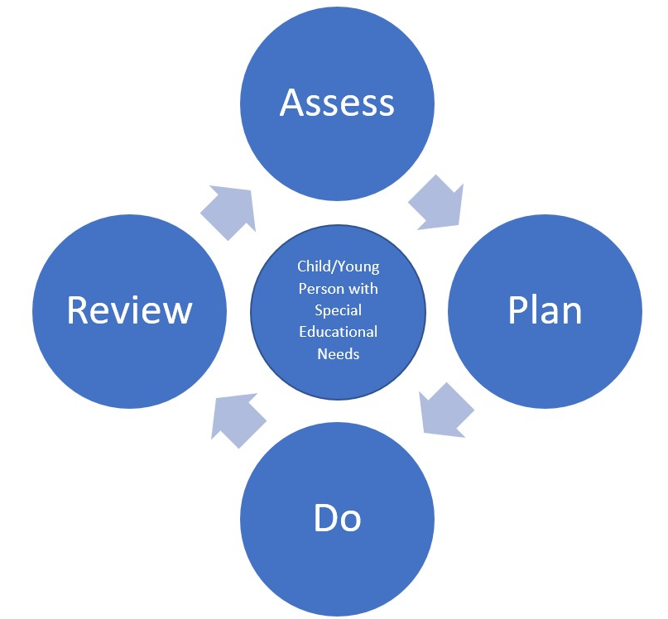
- Assess: establishing a clear assessment of the pupil’s needs.
- Plan: agreeing the adjustments, interventions and support to be put in place, as well as the expected impact on progress, development or behaviour, along with a clear date for review.
- Do: implementing the agreed interventions and support.
- Review: analysing the effectiveness of the interventions and their impact on the pupil’s progress in line with the agreed review date.
The school will consider whether additional pastoral support and attention for pupils with SEND is required, alongside ensuring that any appropriate support for communication is in place.
The class teacher will regularly consider evidence of assessment in conjunction with the views of pupil and parents to review impact that the intervention / support has had and in consultation with the SENDCO review any further need for support. Where there is a sustained period of insufficient or no progress, the school may decide to gain involvement and advice from a specialist. The school will consult with parents before involving a specialist.
We evaluate the effectiveness of provision for pupils with SEND by:
- Reviewing pupils’ individual progress towards their goals each term in Pupil Progress meetings
- Reviewing the impact of interventions after each half term
- Monitoring by the SENDCO
- Holding annual reviews for pupils with EHC plans
- Reviewing and sharing SEND documentation with parents/carers termly.

Assessing and reviewing pupils' progress towards outcomes
The class or subject teacher will work with the SENDCO to carry out a clear analysis of the pupil’s needs. This will draw on:
- The teacher’s assessment and experience of the pupil
- Their previous progress, attainment and behaviour
- Other teachers’ assessments, where relevant
- The individual’s development in comparison to their peers and national data
- The views and experience of parents
- The pupil’s own views
- Advice from external support services, if relevant
The assessment will be reviewed regularly.
All teachers and support staff who work with the pupil will be made aware of their needs, the outcomes sought, the support provided, and any teaching strategies or approaches that are required. We will regularly review the effectiveness of the support and interventions and their impact on the pupil’s progress.
Where higher levels of need are identified, the school may access specialised assessments from external agencies and professionals.
Where, despite the school having taken relevant and purposeful action to identify, assess and meet the SEN of a pupil, they have not made expected progress, the school, in consultation with parents, will consider requesting an Education, Health and Care needs assessment.

Safeguarding
Evidence shows pupils with SEND are at a greater risk of abuse and maltreatment, so will ensure that staff are aware that pupils with SEND:
- Have the potential to be disproportionately impacted by behaviours such as bullying.
- May face additional risks online, e.g. from online bullying, grooming and radicalisation.
- Are at greater risk of abuse, including child-on-child abuse, neglect, and sexual violence and harassment.
The school recognises that there are additional barriers to recognising abuse and neglect in this group of pupils. These barriers can include, but are not limited to:
- Assumptions that indicators of possible abuse such as behaviour, mood and injury relate to the pupil’s condition without further exploration.
- These pupils being more prone to peer group isolation or bullying (including prejudice-based bullying) than other pupils.
- The potential for pupils with SEND or certain medical conditions being disproportionally impacted by behaviours such as bullying, without outwardly showing any signs.
- Communication barriers and difficulties in managing or reporting these challenges.
- The need for intimate care or that these pupils are isolated from others.
- Increased dependence on adults for care.
- A different cognitive understanding and being unable to understand the difference between fact or fiction in online content.

Care will be taken by all staff, particularly those who work closely with pupils with SEND, to notice any changes behaviour or mood, or any injuries, and these indicators will be investigated by the DSL in collaboration with the SENCO.
School staff will be particularly alert to the potential need for early help for pupils with SEND and additional needs.
The governing board and headteachers will ensure that pupils with SEND are taught about how to keep themselves and others safe including online. The school will ensure that teaching of safeguarding is tailored to the specific needs and vulnerabilities of pupils with SEND.
Any reports of abuse involving pupils with SEND will involve close liaison between the DSLs. The SENDCO is also a DSL.

EAL
The school recognises that having EAL does not equate to having SEND. Where pupils with EAL make slower progress, the school will carefully assess whether this relates to language acquisition or an underlying special educational need. Consideration will be given to the pupil’s home language, culture, prior educational experience, and broader development. Support will be tailored accordingly and based on evidence-informed practice.
Training and CPD
All staff in the school will be provided with training or information to meet the needs of children with SEND within their classroom. The SENDCO will make herself aware of relevant courses relating to SEND which staff can request access to and can advise as necessary. All staff have access to training, including teaching assistants. The SENDCO will complete an annual CPD needs audit of teachers and teaching assistants. Attendance on courses is usually planned in relation to staff need and decisions about staff development are based on this. The SENDCO will attend relevant SEND courses and then will share relevant CPD with teachers at a Teaching and Learning meeting every term.

Occasionally, specialised training will be necessary to support the needs of a particular pupil. This will be provided to those staff most directly involved with the pupil. There is an expectation that staff who receive training will disseminate their knowledge to others, to benefit all working with SEND pupils.

Responsibilities and contacts
SENDCO- Rebecca Jennings
SEND Governor- Adam Masterson
Headteachers- Natasha Hall and Hannah McConnell
All of the above can be contacted via office@mulbartonprimary.norfolk.sch.uk

The SENDCO will:
- Work with the headteachers and SEND governor to determine the strategic development of the SEND policy and provision in the school.
- Have day-to-day responsibility for the operation of this SEND policy and the co-ordination of specific provision made to support individual pupils with SEND, including those who have EHC plans.
- Provide professional guidance to colleagues and work with staff, parents, and other agencies to ensure that pupils with SEND receive appropriate support and high quality teaching.
- Advise on the graduated approach to providing SEND support.
- Advise on the deployment of the school’s delegated budget and other resources to meet pupils’ needs effectively.
- Be the point of contact for external agencies, especially the local authority and its support services.
- Liaise with previous providers and potential next providers of education to ensure pupils and their parents are informed about options and a smooth transition is planned.
- Work with the headteachers and governing board to ensure that the school meets its responsibilities under the Equality Act 2010 with regard to reasonable adjustments and access arrangements.
- Liase with the parents of pupils with SEND.
- Ensure the school keeps the records of all pupils with SEND up to date.
The SEND governor will:
- Help to raise awareness of SEND issues at governing board meetings.
- Monitor the quality and effectiveness of SEND and disability provision within the school and update the governing board on this.
- Work with the headteachers and SENDCO to determine the strategic development of the SEND policy and provision in the school.
The headteachers will:
- Work with the SENDCO and SEND governor to determine the strategic development of the SEND policy and provision in the school.
- Have overall responsibility for the provision and progress of learners with SEND.
Class teachers will:
Each class teacher is responsible for:
- The progress and development of every pupil in their class.
- Working closely with any teaching assistants or specialist staff to plan and assess the impact of support and interventions and how they can be linked to classroom teaching. To ensure teaching assistants are aware of the individual needs of the children in the class.
- Working with the SENDCO to review each pupil’s progress and development and decide on any changes to provision.
- Ensuring they follow this SEND policy, setting high expectations for every pupil, aiming to teach them the full curriculum, whatever their prior attainment.
Supporting pupils moving between phases
The school is aware of the importance of planning and preparing for the transitions between phases of education.
We will share information with the school, college, or other setting the pupil is moving to.
All pupils moving to a new school will be offered a visit, organised to familiarise them with the new school environment and teachers prior to the date of transfer.
For our children with SEND, it may be necessary to provide additional opportunities to develop relationships with staff and familiarity with their new school environment. These additional transition arrangements will be provided in response to a child’s individual needs and identified through discussion between schools and families.
Transition Planning Meetings
During the last term of each academic year transition planning meetings will take place for all children changing class within the same school. Current teachers will meet with new teachers. These meetings are to discuss a child’s strengths, interests and any additional needs they may have. They will share ways that those additional needs are being met, including what has worked well and what has not been so successful.
Where a child will be starting a new school, the SENDCO and teacher(s) will meet with the SENDCO at their new school where possible. The meetings aim to provide as much information as possible to the new school about the child. This is so that they can ensure preparations are made to welcome the child and make their transfer to their new school as smooth and successful as possible.
Transfer of information
The school keep records to track a child’s academic and social achievements, attainment and progress (including results from any assessments and reports from the health service or other professionals) together with information about any additional support they have been providing for the child. This information will be shared with the new school at transition planning meetings and passed to the new school when the child transfers to inform future decisions about how best to support and develop the child’s wellbeing, skills and learning.
If a child has an EHC plan, the SENDCO and teacher (if known) from their new school will be invited to the annual review meeting. This will be held before the child transfers to their new school.
Starting school
Before a child starts in a Reception class at school, staff from the school may arrange to visit the child in their pre-school setting. Visits to the pre-school setting allow the child’s new teacher to see how they interact with other children. Additionally, the child is likely to be invited to attend sessions in their new school. This will provide opportunity to meet their new friends and teachers, and to find out about things that are important to them.
Changing year group
During the summer term, all children moving to a new class within school will meet their new teacher in their new classroom during transition days. It may be appropriate for extra visits to be arranged and/or for their new teachers to visit them in their current classroom. Additional resources such as social stories and photographs of staff may be created for some children. If a child is anxious about their new environment, they may be invited to visit the classroom in September on an INSET day prior to the school reopening.
Moving to a new school
Children changing schools are likely to be invited to visit their new school to join in activities designed to help them become familiar with their new school and classroom and meet staff and other pupils that they will see regularly in school. During these visits, children are shown the things that are important to them. For example, where lunch boxes are kept, what the dining room looks like, where the toilets are and where to find their peg.
Visits and activities are tailored to be enjoyable and reassuring for the child. The number of visits will be agreed as appropriate dependent on the needs and wishes of the child. Some children may need or wish for more visits than others. It may also be appropriate for a child’s new teachers to visit them in their current school.

Complaints about SEND provision
Concerns about SEND provision in our school should be made to the class teacher in the first instance. Where is is not possible to resolve these issues they will then be referred to SENDCO and if appropriate the school’s complaints policy.
The school is aware of the formal and informal arrangements for resolving disagreements at a local level and will work with the LA in responding to requests for information as part of procedures for:
- Disagreement resolution.
- Mediation.
- Appeals to the SEND Tribunal.

