
This is the knowledge organiser for our topic. It includes all the learning outcomes, key facts and vocabulary. Please share this with your child to help them develop their knowledge and understanding of our topic.
Year 3 – Spring 2
Title of topic: Rivers and Coasts
Topic Focus – Geography - rivers.

Topic focus:
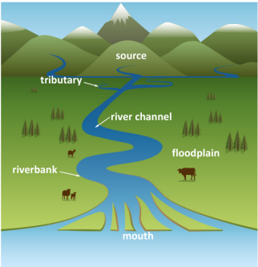
Key vocabulary:

River – a flow of fresh water across the land into a lake, sea or ocean.
Source - where the river starts.
Lake - a large area of water, surrounded by land. Sea An area of salt water.
Tributary – a river or stream that flows into a larger river.
River Channel – a route along which water travels
Riverbed - the bottom of a river.
Riverbank – the land at the edge of a river.
Mouth – the end of the river where the water flows into a sea or lake.
Flood Plain – an area of flat land which floods when a river is too full.
Confluence - the junction of two rivers.
Waterfall - a cascade of water falling from a height, formed when a river or stream flows over a steep incline
Dam - a barrier that stops or restricts the flow of water or underground streams.

Using Rivers.
In the past rivers provided food and fresh water for drinking and washing. Farmers grew crops near rivers because the soil was fertile. The power of flowing water was also used by machines, such as water wheels, to make flour and wood pulp. Trade routes often used rivers to transport goods by boat. Rivers also provided a densive barrier against invaders. Today, rivers are used for leisure activies like fishing, caneoing and rowing.
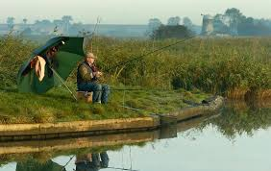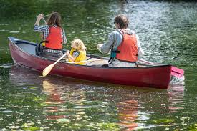
Aquatic Plants
Aquatic plants have adapted to live in water. Some live on the surface whilst others live underwater.
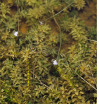
Waterlily Canadian
pondweed
Local Rivers.
Our local rivers are the River Waveney, River Yare and River Tay

World Rivers.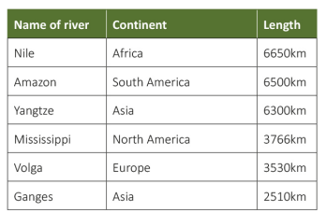
Physical features of river
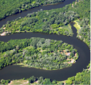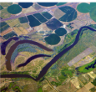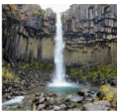
Meander Ox-bow Lake Waterfall
A meander is a bend in a An ox-bow lake is a lake A waterfall is water that
river. It is formed when that was a meander in a falls from a higher
fast-flowing water erodes river. The bend is cut off level to a lower level.
the bank and deposits mud when the river finds a
or silt within the bend. straighter, easier course
to follow.
Parts of a river.

In the past, people believed many strange things about the treatment of disease and illness. People did not know about germs and believed that illness could be spread by smells.

Operations were nearly always carried out without anaesthetics until the 19th Century. Since then, many different anaesthetics have been invented and discovered.

