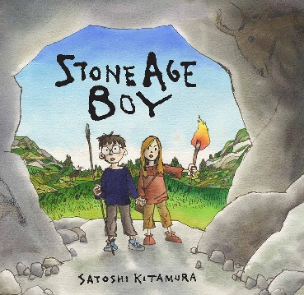  Stone Age Boy  This curriculum map provides an overview of what your child is learning in Year 3 this half term |  |  | Maths  As mathematicians, the children will be developing their knowledge of multiplication and division. They will begin to multiply and divide a two-digit number by a one-digit numbers. The children will then move onto learning about units of measurement in length and begin to explore perimeter. | Humanities  As historians, children will be investigating British History back to the Stone Age, including how Britain changed from the Stone Age to the Iron Age. They will understand how discovery and use of metals like bonze and iron change the way that people lived and worked.
Science  As scientists, children will learn about skeletons and how they support the body for both animals and humans. We will look at how a muscle works within the body. |  | English  As writers, the children will continue to develop their writing to entertain skills and will be exploring and writing a historical narrative with a focus on adding historical detail to characters, setting and events.  Our Guided Reading sessions will support our learning about the Stone Age. | Art/DT  In Design Technology, children will be designing, making and evaluating their own posters that include mechanisms. Children will use card strips and split pins to make a moving poster for information about the Stone Age. | French  As linguists, the children will study the unit ‘les instruments’ and will learn the names of instruments as well as being introduced to the verb ‘to play’.
PSHE / RE  For PSHE, the children will continue to focus on the zones of regulation, how to recognise the different zones in our body and what we can do to manage those feelings.  In RE, children will be learning about Christianity and the Trinity. | PE  • | PE  As sportspeople, children will develop their skills in gymnastics and stretching/flexibility. | Computing  In Computing, the children will be revisiting online safety as well as using the internet for research. They will use data and information software to search on a database and collate their own information. | Music  As musicians, the children will be learning skeleton dancing and songs about the human body. Percussion instruments will be used to improvise and create word rhythms. They will also be enhancing their French language learning through songs.

