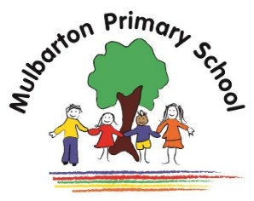
This is the knowledge organiser for our topic. It includes all the learning outcomes, key facts and vocabulary. Please share this with your child to help them develop their knowledge and understanding of our topic.
Year 3 – Summer 2 (2nd half)
Title of topic: Forces and Magnets

Topic focus:
