
This is the knowledge organiser for our topic. It includes all the learning outcomes, key facts and vocabulary. Please share this with your child to help them develop their knowledge and understanding of our topic.
Year 3 – Spring 1st half
Title of topic: Hunter and the Hunted
Topic Focus – Science-animals, food chains and skeletons.

Topic focus:
Predators, prey and decomposers
A predator is an animal that hunts, kills and eats other animals. An apex predator is at the top of the food chain and isn't hunted by any other animal. The animals that predators hunt and kill for food are called prey. A decomposer eats dead plants and animals, releasing nutrients into the soil for plants to take in through their roots. Some bacteria, fungi, insects and worms are decomposers.
Food Chain
Food provides energy for all living things. Energy is needed for life processes, including breathing, growth and movement. Food chains show how energy passes from one plant or animal to another.
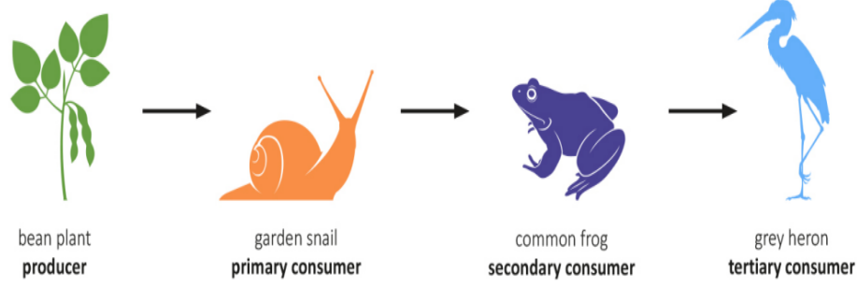
Diet
Animals that only eat meat are carnivores.
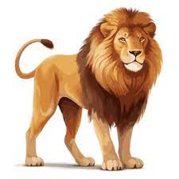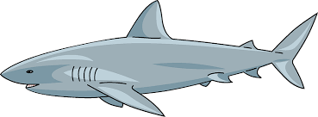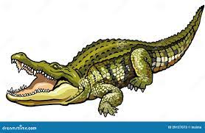
Animals that only eat plants are herbivores.
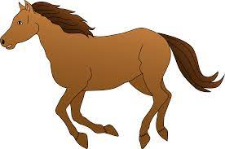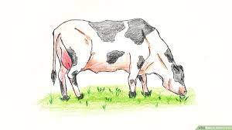
Animals that eat meat and plants are omnivores.
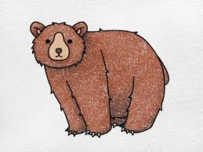
Skeletons
Endoskeleton  Endoskeletons grow inside the body as the animal grows and are permanent. They protect important organs and support movement.. | Exoskeleton  Found on the outside of an animal’s body. They provide armour to defend the animal from predators and stops them drying out. | Hydroskeleton  Animals with no bones or hard structures. Allows animals to move and heal quickly.
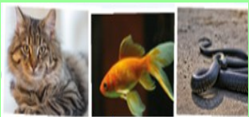 | 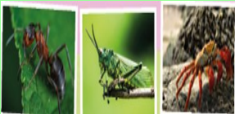 | 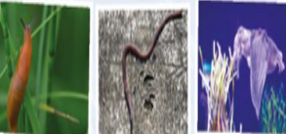
Examples: cats, fish and snakes. | Examples: ants, grasshoppers and crabs | Examples: slugs, earthworms and squid.

In the past, people believed many strange things about the treatment of disease and illness. People did not know about germs and believed that illness could be spread by smells.

Operations were nearly always carried out without anaesthetics until the 19th Century. Since then, many different anaesthetics have been invented and discovered.

