Mulbarton Primary School – Year 6 Curriculum Map – Autumn 2

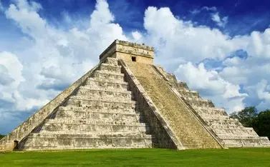 | Eerie Adventures |  |  |  |  | 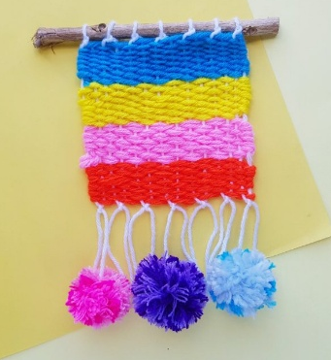
 | This curriculum map provides an overview of what your child will be learning across the curriculum this half term.
As readers we will engage with the books ‘The Watertower’, ‘Malamander’ and ‘The Curse of the Maya’ taking part in a variety of activities to support comprehension.  As writers we will be writing  narrative related to the book, focusing on creating tension and suspense. |  | As historians we will be learning about the ancient civilisations of the Mayans |  |  | As mathematicians, we will be learning about fractions and measurement - utilising our previous knowledge of place value and the four operations to answer questions.
In Design and Technology our focus will be on textiles and combining fabrics.
Our project will be to create a wall hanging.
In computing we will be learning about computing systems and networks. | In R.E. we will be exploring the following question – How do you explain suffering in the world? |  | As scientists we will learn all about light and how it travels. | In P.E. we will focusing on dance and basketball. |  | In French we will focus on learning the language and vocabulary of ‘les planètes’ (planets).
This curriculum map is correct at the time of going to print but is subject to change. If you have any questions about our curriculum please speak to your child’s class teacher.

