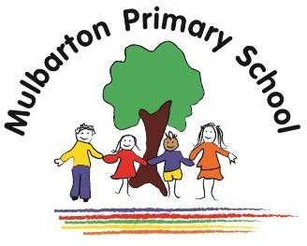

Year 6 – Autumn 2
Eerie Adventures
Topic focus: Science & History
This is the knowledge organiser for our topic. It includes all key facts and vocabulary. Please share this with your child to help them develop their knowledge and understanding of our topic.

